
September 1, 2025
Bedford Primary School

Reception Curriculum
High Quality Texts
Autumn 1 | Autumn 2 | Spring 1 | Spring 2 | Summer 1 | Summer 2
Marvellous Me | Once Upon a Time | On the Move | Amazing Animals | Under the Sea | Superheroes
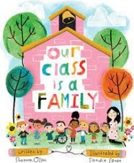  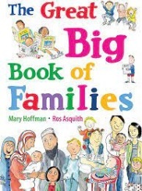  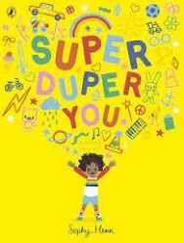  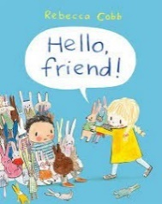 | 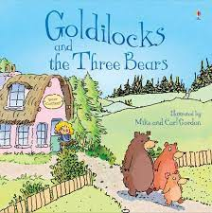  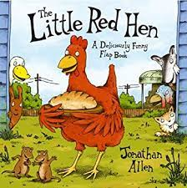 | 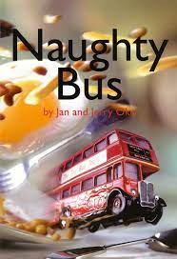  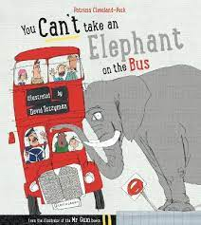  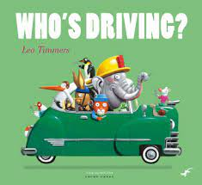 | 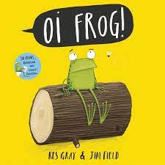  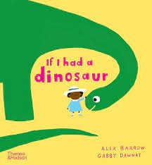  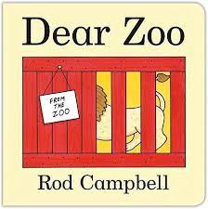 | 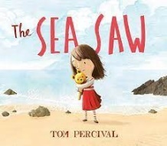  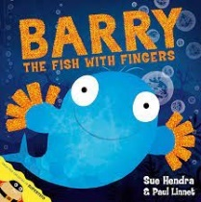  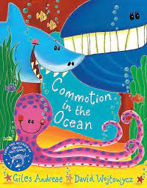 | 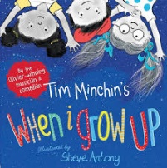  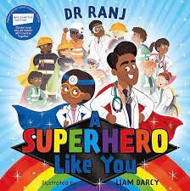  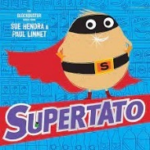
High Quality Texts linked to Time of Year
Autumn 1 | Autumn 2 | Spring 1 | Spring 2 | Summer 1 | Summer 2
Autumn Walks | Sparkle & Shine | Winter Walks | New Life | Spring Walks | When I Grow Up
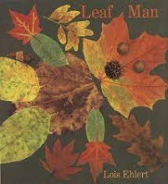  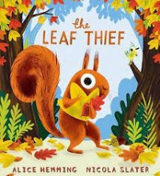  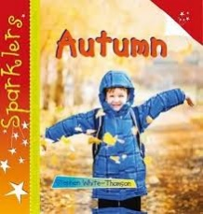 | 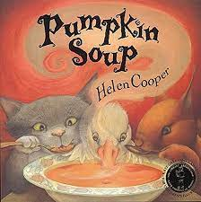  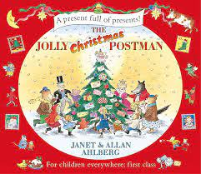     | 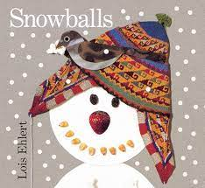  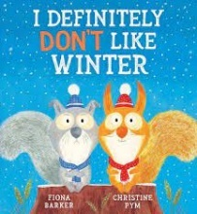    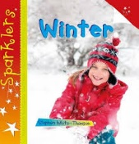 | 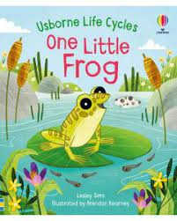  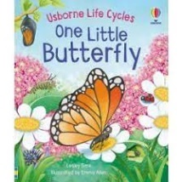  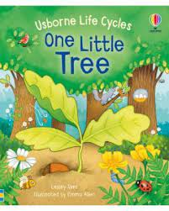 | 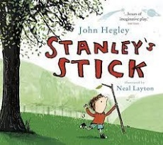  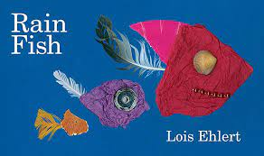  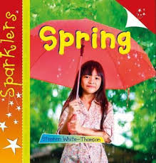 | 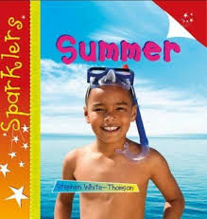  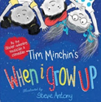

 | Autumn 1 | Autumn 2 | Spring 1 | Spring 2 | Summer 1 | Summer 2
Theme | Marvellous Me | Once Upon a time | On the move | Amazing animals | Under the sea | Superheroes
Key texts | Our Class is a Family by Shannon Olsen  The Great Big Book of Families by Mary Hoffman  Super Duper You by Sophy Henn  Hello Friend by Rebecca Cobb | Little Red Hen by Jonathan Allen or story sack  Goldilocks and the Three Bears by Susanna Davidson or story sack | Who’s Driving by Leo Timmers  You can’t take an Elephant on the bus by Patricia Cleveland - Peck  Naughty Bus by Jan Oke | Dear Zoo  If I had a Dinosaur by Gabby Dawnay  Oi Frog by Kes Gray | Commotion in the Ocean: Giles Andreae  Barry the fish with fingers by Sue Hendra  The Sea Saw by Tom Percival | Supertato by Paul Linnett and Sue Hendra  A Superhero like you by Dr Ranj
Key Texts linked to Time of Year | Autumn Walks  Leaf Man by Lois Ehlert  The Leaf Thief by Alice Hemming | Sparkle and Shine Theme  Pumpkin Soup by Helen Cooper  It’s Diwali by S and K Sehgal  Dear Santa by Rod Campbell  The Jolly Christmas Postman | Winter Walks  Snowballs by Lois Ehlert  I definitely don’t like winter by Fiona Barker  My first Chinese New Year by Karen Katz | New Life  Usborne ‘One Little’ books | Summer Walks  Rain Fish by Lois Ehlert  Stanley’s Stick by John Hegley | When I Grow up  When I grow up by Tim Minchin
Key questions/focus | Who are you?  What makes you special?  What do you like to do?  What do you look like?  Who is your family?  Who looks after you?  Who lives in your house?  What makes a good friend?  How can we look after our classroom?  How can we look after each other?  Book cover/title/ blurb etc… | What traditional tales do you know?  What happens first/next/in the end?  Can you read the next part? (repetitive)  Who are the main characters?  Where is this book set?  What things do you and your family celebrate?  How do you celebrate them? | How many different ways can you travel?  How do you travel to school?  What footwear do you wear for different journeys?  What journeys have you been on?  How did you get there?  Where do you go on special journeys?  Have you been on a bus/boat etc…?  What person would go in this vehicle? How do you know?  What noises would this vehicle make?  What features does this vehicle have? | What animals would you find in the zoo/farm/home?  Can you describe the different animals?  Why couldn’t you have this animal as a pet?  What does this animal need?  What words rhyme with …? | Have you ever been to the beach?  What would you find at the beach?  What would you find on the sand/ in the ocean?  Can you describe this animal that lives in the ocean?  Can you describe the sand?  Can you describe the water?  What is your most favourite/precious thing?  How would you feel if you lost it? | Would you like to be a superhero?  Who is your favourite superhero?  What does your favourite super hero look like?  What is their superpower?  Do you have any super powers?  Do all superheroes wear capes?  Who else can be superheroes?  What superpowers do these people have?  What would you like to do when you grow up?  What superpowers would you like to have?
Wow moments/key events | *First day of school certificate  *First day of school selfie frame  *Starting school poster (all about me)  *Meeting our class bear – taking him home for the weekend  *Autumn walk | *Re-telling familiar stories (Pie Corbett)  *Make pumpkin soup – Halloween  *Bonfire Night artwork  *Diwali visitor  *Trip to the post office/box to post letters to Santa  *Santa visit | *Ramadam  *Freezing and melting  *Winter wellie ‘’bear hunt’ walk  *Train ride  *Fire engine visit  * Chinese New Year banquet  *Chinese New Year role play restaurant | ^Animal visit to school  *Farm visit  *Minibeast hunt  *Planting and growing  *Growing butterflies  *Easter egg hunt | *Trip to the beach  *Summer walk  *Picnic outside  *Ice Cream parlour role play | *People in the community visits to talk about their jobs  *Meet the new teacher
Nursery rhymes and poems | Twinkle Twinkle  Ring a Ring O’Roses  Head Shoulders Knees and Toes  If you’re Happy and you Know it  Wind the Bobbin Up  I’m a Little Teapot  Rain Rain Go Away | Humpty Dumpty  Jack and Gill  1, 2, 3, 4, 5 Once I Caught a Fish Alive  Hickory Dickory Dock  Two Little Dicky Birds  Little Miss Muffet  Little Jack Horner | The Wheels on the Bus  Row Row Row your Boat  Hop Little Bunny  Pat a Cake  Mary Mary Quite Contrary  The Muffin Man | Incy Wincy Spider  Hey Diddle Diddle  5 Little Ducks  Baa Baa Black Sheep  5 Little Speckled Frogs  Old McDonald Had a Farm  Mary Had a Little Lamb | 10 Fat Sausages  10 Green Bottles  5 Little Monkeys Jumping on the Bed | London Bridge is Falling Down
‘20’ super stories | 1. The invisible string by Patrice Karst  2. Elmer by David McKee  3. The Rainbow Fish by Marcus Pfister  4. I love Me by Marvyn Harrison  5. You Choose by Nick Sharrat | 6. Room on The Broom by Julia Donaldson  7. Gingerbread Man  8. The Three Little Pigs  9. Little Red Riding Hood  (Xmas box of books also) | 10. We’re going on a Bear Hunt by Michael Rosen  11. We’re going on a Lion Hunt by David Axtell  12. The Train Ride by June Crebbin | 13. Handa’s Surprise by Eileen Brown  14. The Very Hungry Catterpillar by Eric Carle  15. What the Ladybird Heard by Julia Donaldson  16. The Tiger who came to Tea by Judith Kerr | 17. The Snail and the Whale by Julia Donaldson  18. Somebody Swallowed Stanley by Sarah Roberts | 19. People Who Help Us by John Wood  20. Superworm by Julia Donaldson
Non fiction | St Helen’s box of book on Families and autumn | St Helens box of books on Diwali and Nativity/Xmas/  Winter | St Helens box of vehicles books and winter books | Little Kids First Big Book of Dinosaurs | St Helens box of ocean/seaside books and summer books | St Helens box of people who help us books

Communication and Language
Educational Programme: The development of children’s spoken language underpins all seven areas of learning and development. Children’s back-and-forth interactions from an early age form the foundations for language and cognitive development. The number and quality of the conversations they have with adults and peers throughout the day in a language-rich environment is crucial. By commenting on what children are interested in or doing, and echoing back what they say with new vocabulary added, practitioners will build children's language effectively. Reading frequently to children, and engaging them actively in stories, non-fiction, rhymes and poems, and then providing them with extensive opportunities to use and embed new words in a range of contexts, will give children the opportunity to thrive. Through conversation, story-telling and role play, where children share their ideas with support and modelling from their teacher, and sensitive questioning that invites them to elaborate, children become comfortable using a rich range of vocabulary and language structures.
AUTUMN | SPRING | SUMMER
Listening, Attention and Understanding: | Listening, Attention and Understanding:  Listen carefully.  Learn new vocabulary – linked to school life and theme: On the Move, Amazing Animals, Spring and Celebrations  - Engage in story times – sit for longer periods of time and join in with repeated refrains / fill in rhyming words.  - Listen to and talk about stories to build familiarity and understanding – using colourful semantics, reinforce the who (orange), doing (yellow). Consolidate the where (blue) and what (green).  - Listen carefully to rhymes and songs and pay attention to how they sound.  - Listen to and begin to talk about selected non-fiction to develop a familiarity with new knowledge and vocabulary.  Speaking:  Use talk to help work out problems and organise thinking and activities, and to explain how things work and why they might happen.  Engage in non-fiction books.  Articulate their ideas and thoughts in well-formed sentences.  Use new vocabulary throughout the day.  Ask questions to find out more and to check they understand what has been said to them.  Connect one idea or action to another using more connectives – and, but, because, so, then  Describe events in some detail – their news, their day, celebrations, trips  Develop social phrases – greetings, register, speaking to our friends.  Retell the story, once they have developed a deep familiarity with the text, some as exact repetition and some in their own words – using Pie Corbett, Lots of re-reading texts and nursery rhymes  Use new vocabulary in different contexts. | Listening, Attention and Understanding:  Listen attentively and engage in story times and nursery/song times confidently.  Learn new vocabulary – linked to school life and theme: Under the Sea, Superheroes, Summer and Celebrations.  - Listen to and talk about stories to build familiarity and understanding – using colourful semantics, reinforce the who (orange), doing (yellow), the where (blue) and what (green). Introduce the when (brown)  - Listen to and talk about selected non-fiction to develop a familiarity with new knowledge and vocabulary.  Speaking:  Use talk to help work out problems and organise thinking and activities, and to explain how things work and why they might happen.  Engage in non-fiction books.  Articulate their ideas and thoughts in well-formed sentences.  Use new vocabulary throughout the day.  Ask questions to find out more and to check they understand what has been said to them.  Connect one idea or action to another using a range of connectives.  Describe events in some detail.  Develop social phrases.  Retell the story, once they have developed a deep familiarity with the text, some as exact repetition and some in their own words.  Use new vocabulary in different contexts.
  Understand how to listen carefully and why listening is important.
  - Learn new vocabulary – linked to daily routine and theme: Me and my Family, Autumn, Once Upon a Time and Celebrations
  - Begin to engage in story times – sit for longer periods of time and join in with repeated refrains / fill in rhyming words.
  - Listen to and begin to talk about stories to build familiarity and understanding – using colourful semantics, introduce the who (orange), doing (yellow). Introduce where (blue) and what (green) – later on in the Autumn term)
  - Listen carefully to rhymes and songs and begin to pay attention to how they sound.
  - Speaking:
  Begin to articulate their ideas and thoughts in well-formed sentences.
  Use new vocabulary throughout the day.
  Begin to ask questions to find out more and to check they understand what has been said to them – Model using sentence stems and colourful semantics.
  Begin to connect one idea or action to another using some connectives – and, but, because
  Begin to describe events in some detail – their news, their day
  Develop social phrases – greetings, register, speaking to our friends.
  Begin to retell the story, once they have developed a deep familiarity with the text, some as exact repetition and some in their own words – using Pie Corbett, Lots of re-reading texts and nursery rhymes
  Use new vocabulary in different contexts.

Personal, Social and Emotional Development
Children’s personal, social and emotional development (PSED) is crucial for children to lead healthy and happy lives, and is fundamental to their cognitive development. Underpinning their personal development are the important attachments that shape their social world. Strong, warm and supportive relationships with adults enable children to learn how to understand their own feelings and those of others. Children should be supported to manage emotions, develop a positive sense of self, set themselves simple goals, have confidence in their own abilities, to persist and wait for what they want and direct attention as necessary. Through adult modelling and guidance, they will learn how to look after their bodies, including healthy eating, and manage personal needs independently. Through supported interaction with other children, they learn how to make good friendships, co-operate and resolve conflicts peaceably. These attributes will provide a secure platform from which children can achieve at school and in later life.
AUTUMN | SPRING | SUMMER
Self Regulation: | Self Regulation: | Self Regulation:
  Talk with others to solve conflicts – Talk about being fair, taking turns, sharing.
  Begin to compromise and learn how to solve problems.
  Begin to express their feelings and understand how others might be feeling using words like ‘happy’, ‘sad’, ‘angry’, ‘frightened’ or ‘worried’.
  Begin to identify and moderate their own feelings socially and emotionally – keeping calm, explaining what is upsetting them, waiting their turn, sharing, tidying up after themselves.
  Managing Self:
  Manage own self care needs – putting coat on and zipping it up, taking jumper on and off, putting own Velcro shoes on, buttoning and unbuttoning trousers at toilet time, get own snack, toileting self.
  Know and begin to talk about the different factors that support their overall health and wellbeing: - regular physical activity, healthy eating, toothbrushing
  Building Relationships:
  Begin to see self as an individual and describe themselves and others positively.
  Begin to build constructive and respectful relationships.
  Express their feelings and understand how others might be feeling using words like ‘happy’, ‘sad’, ‘angry’, ‘frightened’ or ‘worried’.
  Begin to show resilience and perseverance in the face of challenge.
  Identify and moderate their own feelings socially and emotionally – keeping calm, explaining what is upsetting them, waiting their turn, sharing, tidying up after themselves.
  Think about the perspective of others.
  Managing Self:
  Manage own self care needs.
  Know and talk about the different factors that support their overall health and wellbeing: - regular physical activity, healthy eating, toothbrushing, screen time, bed time routine, being a good pedestrian
  Building Relationships:
  See self as an individual and describe themselves and others positively.
  Build constructive and respectful relationships.
  Express their feelings and understand how others might be feeling using a range of feeling words.
  Show resilience and perseverance in the face of challenge.
  Identify and moderate their own feelings socially and emotionally.
  Think about the perspective of others.
  Managing Self:
  Manage own self care needs.
  Know and talk about the different factors that support their overall health and wellbeing.
  Building Relationships:
  See self as an individual and describe themselves and others positively.
  Build constructive and respectful relationships.

Physical Development
Physical activity is vital in children’s all-round development, enabling them to pursue happy, healthy and active lives. Gross and fine motor experiences develop incrementally throughout early childhood, starting with sensory explorations and the development of a child’s strength, co-ordination and positional awareness through tummy time, crawling and play movement with both objects and adults. By creating games and providing opportunities for play both indoors and outdoors, adults can support children to develop their core strength, stability, balance, spatial awareness, co-ordination and agility. Gross motor skills provide the foundation for developing healthy bodies and social and emotional well-being. Fine motor control and precision helps with hand-eye co-ordination which is later linked to early literacy. Repeated and varied opportunities to explore and play with small world activities, puzzles, arts and crafts and the practise of using small tools, with feedback and support from adults, allow children to develop proficiency, control and confidence.
AUTUMN | SPRING | SUMMER
Gross Motor Skills:  Revise and refine the fundamental movement skills they have already acquired: rolling, crawling, walking, jumping, running, hopping, skipping and climbing.  Begin to develop the overall body strength, co-ordination, balance and agility.  Begin to use their core muscle strength to achieve a good posture when sitting at a table or  sitting on the floor.  Begin to combine different movements with ease and fluency.  Begin to safely use a range of large and small apparatus indoors and outside, alone and in a group.  Further develop and refine a range of ball skills including: throwing, catching, kicking.  Use different sizes/types of balls.  Begin to develop the skills they need to manage the school day successfully: lining up and queuing, mealtimes  Fine Motor Skills:  Begin to use a comfortable grip with good control when holding pens and pencils – consolidate tripod grip.  Develop their small motor skills so that they can use a range of tools competently, safely and confidently: pencils for drawing and writing, paintbrushes, scissors, knives, forks and spoons. | Gross Motor Skills:  Continue to refine the fundamental movement skills they have already acquired: rolling, crawling, walking, jumping, running, hopping, skipping and climbing.  Begin to progress towards a more fluent style of moving, with developing control and grace.  Develop overall body strength, co-ordination, balance and agility.  Use their core muscle strength to achieve a good posture when sitting at a table or  sitting on the floor.  Combine different movements with ease and fluency.  Confidently and safely use a range of large and small apparatus indoors and outside, alone and in a group.  Further develop and refine a range of ball skills including: passing, batting, aiming.  Develop the skills they need to manage the school day successfully: lining up and queuing, mealtimes  Fine Motor Skills:  Use a comfortable grip with good control when holding pens and pencils – consolidate tripod grip.  Develop their small motor skills so that they can use a range of tools competently, safely and confidently: pencils for drawing and writing, paintbrushes, scissors, knives, forks and spoons.  Begin to develop the foundations of a handwriting style which is fast, accurate and efficient – pencil grip, correct letter formation | Gross Motor Skills:  Refine the fundamental movement skills they have already acquired: rolling, crawling, walking, jumping, running, hopping, skipping and climbing.  Progress towards a more fluent style of moving, with developing control and grace.  Develop overall body strength, co-ordination, balance and agility.  Use their core muscle strength to achieve a good posture when sitting at a table or  sitting on the floor.  Combine different movements with ease and fluency.  Confidently and safely use a range of large and small apparatus indoors and outside, alone and in a group.  Further develop and refine a range of ball skills.  Develop the skills they need to manage the school day successfully.  Fine Motor Skills:  Use a comfortable grip with good control when holding pens and pencils – consolidate tripod grip.  Develop their small motor skills so that they can use a range of tools competently, safely and confidently.  Develop the foundations of a handwriting style which is fast, accurate and efficient – pencil grip, correct letter formation

LITERACY
It is crucial for children to develop a life-long love of reading. Reading consists of two dimensions: language comprehension and word reading. Language comprehension (necessary for both reading and writing) starts from birth. It only develops when adults talk with children about the world around them and the books (stories and non-fiction) they read with them, and enjoy rhymes, poems and songs together. Skilled word reading, taught later, involves both the speedy working out of the pronunciation of unfamiliar printed words (decoding) and the speedy recognition of familiar printed words. Writing involves transcription (spelling and handwriting) and composition (articulating ideas and structuring them in speech, before writing).
AUTUMN | SPRING | SUMMER
Reading: Comprehension/Word Reading:  Begin to read individual letters by saying the sounds for them – RWInc Phonics from Week 3  Begin to blend sounds into words, so that they can read short words made up of known letter-sound correspondences.  Begin to read a few common exception words matched to the school’s phonic programme and tricky word list.  Begin to read simple phrases and sentences: Read Pink Book band.  Writing:  Write their first name with correct letter formation.  Begin to form all lower case letters correctly.  Begin to spell words by identifying the sounds and then writing the sound with letter/s: initial sounds, labels, vc, cvc  Begin to write lists and captions.  Begin to re-read what they have written. | Reading: Comprehension/Word Reading:  Re-read books to build up their confidence in word reading, fluency and understanding and  enjoyment.  Read individual letters by saying the sounds for them.  Read some letter groups that each represent one sound and say sounds for them.  Continue to blend sounds into words, so that they can read short words made up of known letter-sound correspondences.  Read a few common exception words matched to the school’s phonic programme and tricky word list.  Read simple phrases and sentences: Read Red Book band.  Writing:  Write their first name with correct letter formation.  Form all lower case letters correctly.  Begin to form capital letters correctly.  Continue to spell words by identifying the sounds and then writing the sound with letter/s: cvc  Write lists and captions.  Begin to write short sentences with words with known letter-sound correspondences using a capital letter, finger space and full stop.  Continue to re-read what they have written. | Reading: Comprehension/Word Reading:  Re-read books to build up their confidence in word reading, fluency and understanding and  enjoyment.  Read individual letters by saying the sounds for them.  Read some letter groups that each represent one sound and say sounds for them.  Blend sounds into words, so that they can read short words made up of known letter-sound correspondences.  Read a few common exception words matched to the school’s phonic programme and tricky word list.  Read simple phrases and sentences: Read Yellow Book band.  Writing:  Write their first name with correct letter formation.  Form lower-case and capital letters correctly.  Spell words by identifying the sounds and then writing the sound with letter/s.  Write short sentences with words with known letter-sound correspondences using a capital letter, finger space and full stop.  Re-read what they have written to check that it makes sense.

Mathematics
Developing a strong grounding in number is essential so that all children develop the necessary building blocks to excel mathematically. Children should be able to count confidently, develop a deep understanding of the numbers to 10, the relationships between them and the patterns within those numbers. By providing frequent and varied opportunities to build and apply this understanding - such as using manipulatives, including small pebbles and tens frames for organising counting - children will develop a secure base of knowledge and vocabulary from which mastery of mathematics is built. In addition, it is important that the curriculum includes rich opportunities for children to develop their spatial reasoning skills across all areas of mathematics including shape, space and measures. It is important that children develop positive attitudes and interests in mathematics, look for patterns and relationships, spot connections, ‘have a go’, talk to adults and peers about what they notice and not be afraid to make mistakes
AUTUMN | SPRING | SUMMER
Number:  Recite numbers to 10: forwards and backwards, number rhymes, counting from different starting points, talk about position – before/after  Count objects, actions and sounds: up to 5, count in irregular arrangement.  Subitise: 3 or 4 objects  Link the number symbol (numeral) with its cardinal  number value.: to 5  Compare numbers: quantities to 5 – more, less, fewer.  Understand the ‘one more than/one less than’ relationship between consecutive numbers: to 5  Explore the composition of numbers: to 5  Begin to explore number bonds: to 5.  Shape, Space and Measure:  Select, rotate and manipulate shapes to develop spatial reasoning skills – consolidate 2D shape names.  Continue, copy and create repeating patterns.  Begin to compare length, weight and capacity. | Number:  Recite numbers to 20: forwards and backwards, number rhymes, counting from different starting points, talk about position – before/after  Count objects, actions and sounds: up to 10, count in irregular arrangement.  Begin to estimate objects up to 10 and check by counting.  Subitise: 5 objects  Link the number symbol (numeral) with its cardinal number value.: to 10  Compare numbers: quantities to 10 – more, less, fewer.  Understand the ‘one more than/one less than’ relationship between consecutive numbers: to 10  Explore the composition of numbers: to 10  Recall number bonds: to 5.  Shape, Space and Measure:  Select, rotate and manipulate shapes to develop spatial reasoning skills – consolidate 2D shape names.  Begin to compose and decompose shapes so that children recognise a shape can have other shapes within it, just as numbers can.  Continue, copy and create repeating patterns.  Compare length, weight and capacity. | Number:  Count beyond 10.  Count objects, actions and sounds.  Subitise.  Link the number symbol (numeral) with its cardinal number value.  Compare numbers.  Understand the ‘one more than/one less than’ relationship between consecutive numbers.  Explore the composition of numbers: to 10  Recall number bonds: to 5 and some to 10.  Shape, Space and Measure:  Select, rotate and manipulate shapes to develop spatial reasoning skill..  Compose and decompose shapes so that children recognise a shape can have other shapes within it, just as numbers can.  Continue, copy and create repeating patterns.  Compare length, weight and capacity.

Understanding the World
Understanding the world involves guiding children to make sense of their physical world and their community. The frequency and range of children’s personal experiences increases their knowledge and sense of the world around them – from visiting parks, libraries and museums to meeting important members of society such as police officers, nurses and firefighters. In addition, listening to a broad selection of stories, non-fiction, rhymes and poems will foster their understanding of our culturally, socially, technologically and ecologically diverse world. As well as building important knowledge, this extends their familiarity with words that support understanding across domains. Enriching and widening children’s vocabulary will support later reading comprehension.
AUTUMN | SPRING | SUMMER
Past and Present:  Begin to comment on images of familiar situations in the past: When they were a baby/ in nursery, pictures of old celebrations, pictures of mum and dad in the past  People, Culture and Communities:  Talk about members of their immediate family and community: Our Family Topic  Understand that there are many types of families: Great big book of families  Begin to name and describe people who are familiar to them: who lives in their house, their friends, caretakers, head teacher, teachers in class.  Begin to understand that some places are special to  members of their community: Talk about special places they go with their family, places of worship studied and visited by children  Begin to recognise that people have different beliefs  and celebrate special times in different ways: understand how different people celebrate  birthdays, develop a knowledge and awareness of other  festivals: Harvest, Diwali, Christmas  Natural World:  Explore the natural world around them: Leaf Book – Leaves: sort by shape/size/colour, begin to identify  some local tree species, look for signs of Autumn  Describe what they see, hear and feel whilst outside: Leaf shape, size, colour, sound when walking on. e.g. long, spiky, gold, rust, orange, crunchy  Understand the effect of changing seasons on the  natural world around them: Autumn into Winter – Autumn walks | Past and Present:  Comment on images of familiar situations in the past.  People, Culture and Communities:  Talk about members of their immediate family and community.  Name and describe people who are familiar to them.  Understand that some places are special to  members of their community.  Recognise that people have different beliefs  and celebrate special times in different ways:  develop a knowledge and awareness of more  festivals: Chinese New Year, Easter.  Begin to recognise some similarities and differences between life in this country and life in other countries.  Natural World:  Explore the natural world around them: Snowballs Book – look for signs of Autumn  New life books – look for signs of spring  Describe what they see, hear and feel whilst outside: Leaf shape, size, colour, sound when walking on. e.g. green, soft, flowers, blossoms  Understand the effect of changing seasons on the natural world around them: Winter into spring – Winter/spring walks | Past and Present:  Comment on images of familiar situations in the past.  Compare and contrast characters from stories, including figures from the past.  People, Culture and Communities:  Talk about members of their immediate family and community.  Name and describe people who are familiar to them.  Understand that some places are special to  members of their community.  Recognise that people have different beliefs and celebrate special times in different ways.  Recognise some similarities and differences between life in this country and life in other countries.  Natural World:  Explore the natural world around them: Rainfish Book – look for signs of Summer, drawing pictures of plants and animals  Draw information from a simple map.  Describe what they see, hear and feel whilst outside: Leaf shape, size, colour, sound when walking on. e.g. colourful, bees buzzing, hot etc…  Understand the effect of changing seasons on the natural world around them: Spring into summer – Summer walks

Expressive Arts and Design
The development of children’s artistic and cultural awareness supports their imagination and creativity. It is important that children have regular opportunities to engage with the arts, enabling them to explore and play with a wide range of media and materials. The quality and variety of what children see, hear and participate in is crucial for developing their understanding, self-expression, vocabulary and ability to communicate through the arts. The frequency, repetition and depth of their experiences are fundamental to their progress in interpreting and appreciating what they hear, respond to and observe.
AUTUMN | SPRING | SUMMER
Creating with materials:  Draw with increasing complexity and detail, such as  representing a face with a circle and including details: Show different emotions in drawings and paintings  Continue to explore colour and colour mixing.  Safely use and explore a variety of materials and tools:  Explore new techniques, talk about new creations  Being imaginative and expressive:  Take part in simple pretend play - Family / home corner role play, small world  Begin to develop complex stories using small world  Equipment  Begin to develop storylines in their pretend play:  linked to focus theme Once Upon a Time - story language, character, beginning, middle, end  Begin to listen attentively, move to and talk about music, expressing their feelings and responses: How does the music make me feel?  Begin to watch and talk about dance and performance  Art: What type of dance/music is it? … adjectives to  describe music; e.g. happy, sad, slow, fast, bouncy, watch dance performances linked to festivals  Sing in a group or on their own: Engage in circle and partner songs, begin to make own verse for familiar song  Begin to explore and engage in music making and dance | Creating with materials:  Draw with increasing complexity and detail: Show features on the face and different body parts  Safely use and explore a variety of materials and tools.  Explore and use a variety of artistic effects to express: their ideas and feelings.  Return to and build on their previous learning, refining ideas and developing their ability to represent them.  Create collaboratively sharing ideas, resources and skills.  Being imaginative and expressive:  Take part in simple pretend play - Family / home corner role play, small world  Develop complex stories using small world  Equipment  Develop storylines in their pretend play:  linked to focus theme On the move and Amazing animals  Listen attentively, move to and talk about music, expressing their feelings and responses: How does the music make me feel?  Watch and talk about dance and performance  Art.  Sing in a group or on their own.  Explore and engage in music making and dance | Creating with materials:  Explore and use a variety of artistic effects to express their ideas and feelings.  Return to and build on their previous learning, refining ideas and developing their ability to represent them.  Create collaboratively sharing ideas, resources and skills.  Being imaginative and expressive:  Develop storylines in their pretend play:  linked to focus theme Under the Sea and Superheroes  Listen attentively, move to and talk about music, expressing their feelings and responses.  Watch and talk about dance and performance  Art expressing their feelings and responses.  Sing in a group or on their own - increasingly matching the pitch and following the melody.  Explore and engage in music making and dance, performing solo or in groups.

